Metering Installation Error Report

(Data source: explore_1.xlsx. Error calculated: Fri Mar 13 14:06:11 2020.)
The error calculated for the given load profile is +0.14 %.
The expanded uncertainty at an estimated 95% level of confidence is 0.26 %.
The uncertainty interval extends from -0.12 % to +0.39 %.

Installation error over the phase and current ranges that match the load profile.
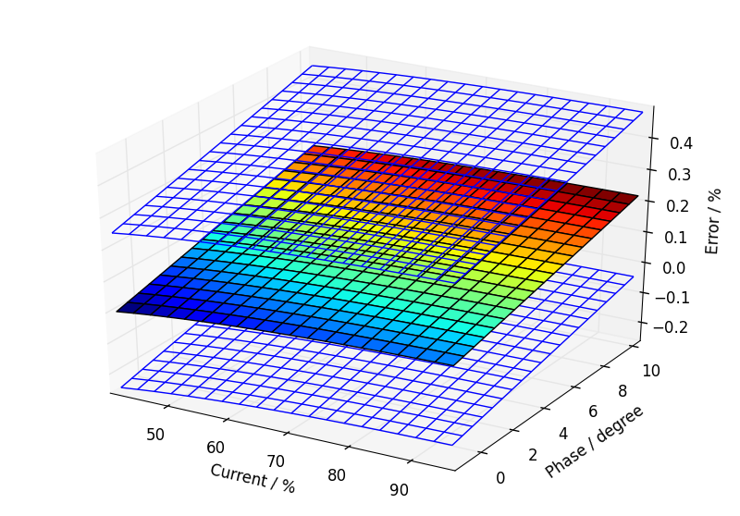

Annual load profile used for this error calculation.
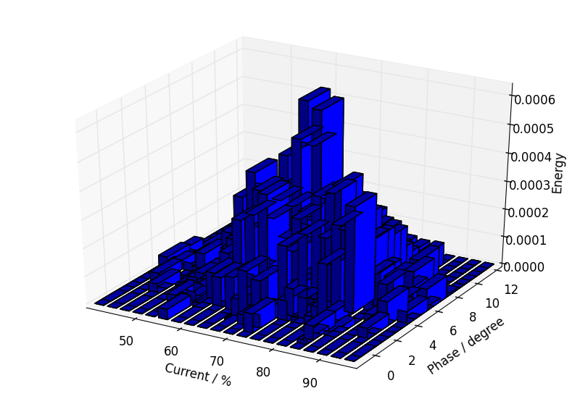

Component calibration data with calculated fits over the calibration ranges.

Current Transformer.
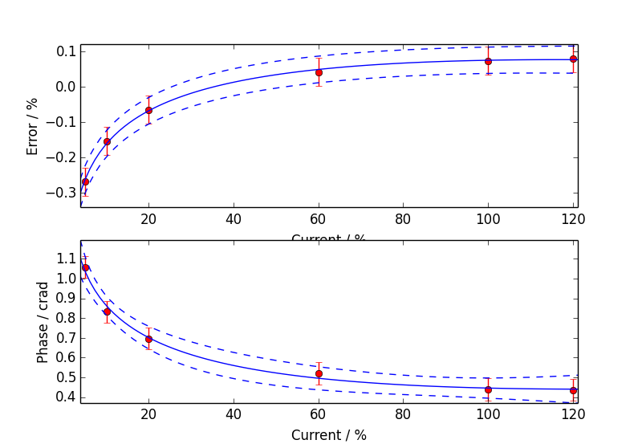

Voltage Transformer.
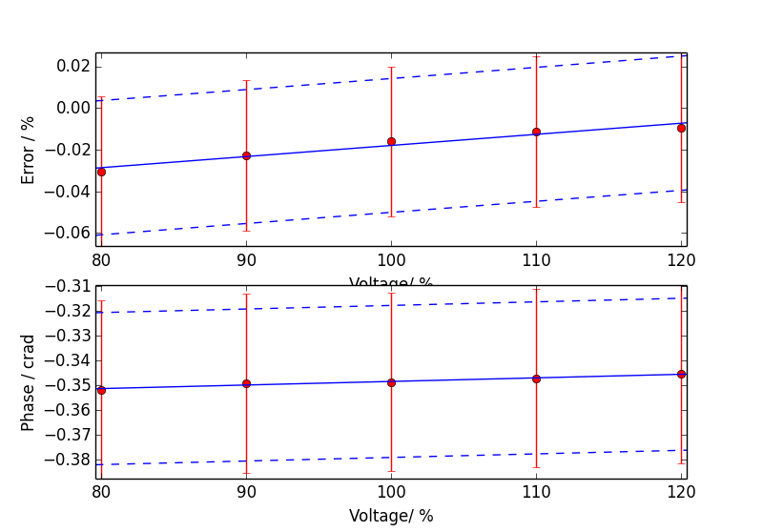

Meter.
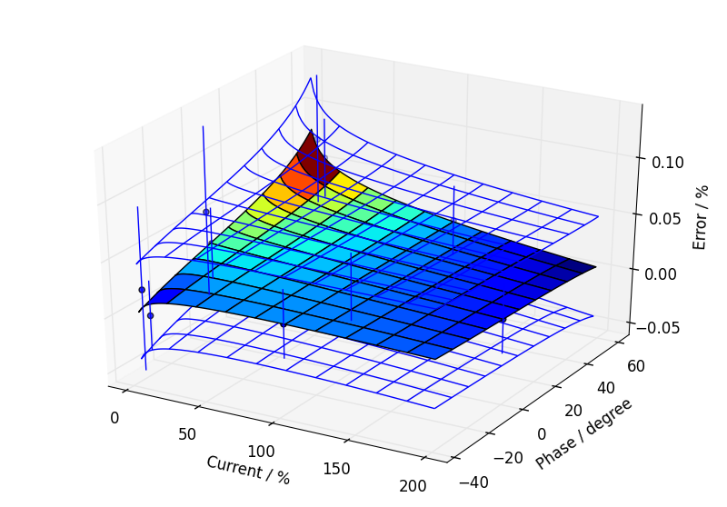

Additional Information

Uncertainty Contribution Summary
Uncertainty contribution by component as a percentage of total variance, Meter: 34 %, CT: 43 %, VT: 23 %.

Text Output From Calculation Process
Meter data
Fit has lower uncertainty than expected from calibration data, so type B component added.
CT ratio data
Fit has lower uncertainty than expected from calibration data, so type B component added.
CT phase data
Good fit.
VT ratio data
Fit has lower uncertainty than expected from calibration data, so type B component added.
VT phase data
Fit has lower uncertainty than expected from calibration data, so type B component added.

Max current = 97.28 %, Min current = 39.88 %, Max phase = 10.61 degrees, Min phase = -1.66 degrees

Budget for overall error by coefficients

0.14, u=0.13, df=43.4
a2 CT_e: 0.0821305
Meter temperature coefficient: 0.0788987
Site temperature: 0.0751666
a0 VT_e: 0.0515479
a1 VT_e: 0.05104
a0 CT_e: 0.0418284
a1 CT_e: 0.0362267
Meter harmonic dependence: 0.0282843
Site harmonics: 0.0282843
Site voltage: 0.0227537
Meter voltage dependence: 0.0212132
b0 meter: 0.0202546
b0 CT_e: 0.0183737
b0 VT_e: 0.0163636
Meter frequency dependence: 0.0132583
Site frequency: 0.0124963
CT calibration burden: 0.0101189
Site CT burden: 0.0101189
a0 meter: 0.00824024
a2 CT_p: 0.00723731
a1 meter: 0.0059021
a0 VT_p: 0.0045432
a1 VT_p: 0.00449843
a0 CT_p: 0.00368657
a1 CT_p: 0.00319006
a3 meter: 0.00162068
b0 VT_p: 0.0013822
a2 meter: 0.00133656
VT calibration burden: 0.00127822
Site VT burden: 0.00127822
CT temperature coefficient of error: 0.000181742
CT temperature coefficient of phase: 0.000129633
VT temperature coefficient of phase: 9.45169E-05
VT temperature coefficient of error: 5.51839E-05
CT calibration temperature: 3.95621E-05
VT calibration temperature: 4.99749E-06

